Step 1 — Install Kubeflow Pipelines SDK
Since you're using Windows, open:
Anaconda Prompt
I recommend creating a separate environment.
Create environment
conda create -n kubeflow python=3.11 -y
Activate:
conda activate kubeflow
Then install KFP:
pip install kfp

This follows the current Kubeflow Pipelines getting-started approach.
Check installation:
python -c "import kfp; print(kfp.__version__)"
You should get something like:
2.x.x

Next: Hands-on 2 — Multi-Step Kubeflow Pipeline

1. Environment
mkdir -p ~/kubeflow-mlops
cd ~/kubeflow-mlops
python3 -m venv .venv
source .venv/bin/activate

2. Install
python -m pip install kfp==2.17.0
python -m pip install pandas scikit-learn joblib
PART-A Hello World with SubprocessRunner
Create the Python file: python subprocess_hello.py
from kfp import dsl
from kfp import local

@dsl.component
def hello(name: str) -> str:
message = f"Hello from KFP SubprocessRunner, {name}!"
print(message)
return message

@dsl.pipeline
def hello_pipeline(name: str = "MLOps Students"):
hello_task = hello(name=name)

local.init(
runner=local.SubprocessRunner(
use_venv=False
),
raise_on_error=False
)

hello_pipeline(name="MLOps Students")

Step 1 — Run this command
From your current directory:
find ~/kubeflow-mlops/local_outputs -type f | sort
Step 2 — Also run
find ~/kubeflow-mlops/local_outputs -type f \( -name "*.log" -o -name "*.txt" -o -name "executor_output.json" \) -print
Then, if you see an executor_output.json, run:
cat ~/kubeflow-mlops/local_outputs/*/hello/executor_output.json

Linux file-permission problem use this:
Step 1 — Check ownership of local_outputs
Run:
ls -ld ~/kubeflow-mlops/local_outputs
Then:
ls -la ~/kubeflow-mlops/local_outputs

Step 2 — Test write permission
Run:
touch ~/ubeflow-mlops/local_outputs/test.txt
Then:
ls -l ~/ubeflow-mlops/local_outputs/test.txt
Remove the test:
rm ~/ubeflow-mlops/local_outputs/test.txt

Step 3 — Clean the old outputs
Since these are only practical files, let's start fresh:
rm -rf ~/kubeflow-mlops/local_outputs/*
Check:
ls -la ~/kubeflow-mlops/local_outputs

Part B: Simple ML Pipeline
Step 1 — Install ML libraries
python -m pip install pandas scikit-learn joblib
Then verify:
python -c "import pandas, sklearn, joblib; print('ML libraries OK')"

Step 2.1 — Create the Python file
Create a file: nano simple_ml_pipeline.py
from kfp import dsl
from kfp import local

@dsl.component(
base_image="python:3.11",
packages_to_install=["scikit-learn"]
)
def load_data():
from sklearn.datasets import load_iris

iris = load_iris()

print("Dataset loaded successfully!")
print(f"Number of samples: {len(iris.data)}")
print(f"Number of features: {iris.data.shape[1]}")
print(f"Number of classes: {len(set(iris.target))}")

@dsl.pipeline
def ml_pipeline():
load_data()

local.init(
runner=local.SubprocessRunner()
)

ml_pipeline()
Step 2.2 — Run it
python simple_ml_pipeline.py

output:
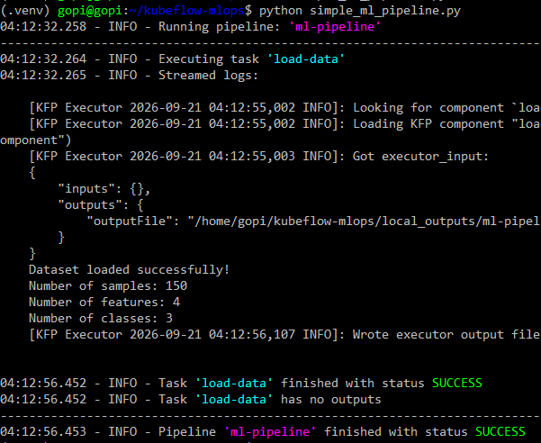

Replace your current file
Open:
nano simple_ml_pipeline.py

from kfp import dsl
from kfp import local
from kfp.dsl import Output, Dataset

@dsl.component(
base_image="python:3.11",
packages_to_install=["scikit-learn", "pandas"]
)
def load_data(dataset: Output[Dataset]):

from sklearn.datasets import load_iris
import pandas as pd

iris = load_iris()

df = pd.DataFrame(
iris.data,
columns=iris.feature_names
)

df["target"] = iris.target

df.to_csv(
dataset.path,
index=False
)

print("Dataset loaded successfully!")
print(f"Number of samples: {len(df)}")
print(f"Number of features: {len(iris.data[0])}")
print(f"Number of classes: {len(set(iris.target))}")

@dsl.component(
base_image="python:3.11",
packages_to_install=["pandas", "scikit-learn"]
)
def preprocess_data(
input_dataset: dsl.Input[Dataset],
processed_dataset: Output[Dataset]
):

import pandas as pd
from sklearn.model_selection import train_test_split

# Read dataset
df = pd.read_csv(input_dataset.path)

# Separate features and target
X = df.drop("target", axis=1)
y = df["target"]

# Train-test split
X_train, X_test, y_train, y_test = train_test_split(
X,
y,
test_size=0.2,
random_state=42
)

# Save training data
train_df = X_train.copy()
train_df["target"] = y_train

# Save testing data
test_df = X_test.copy()
test_df["target"] = y_test

train_df.to_csv(
processed_dataset.path + "_train.csv",
index=False
)

test_df.to_csv(
processed_dataset.path + "_test.csv",
index=False
)

print("Preprocessing completed!")
print(f"Training samples: {len(train_df)}")
print(f"Testing samples: {len(test_df)}")

@dsl.pipeline
def ml_pipeline():

# Step 1: Load data
data_task = load_data()

# Step 2: Preprocess data
preprocess_task = preprocess_data(
input_dataset=data_task.outputs["dataset"]
)

local.init(
runner=local.SubprocessRunner()
)

ml_pipeline()

Then add this component after preprocess_data():
@dsl.component(
base_image="python:3.11",
packages_to_install=["pandas", "scikit-learn", "joblib"]
)
def train_model(
processed_dataset: dsl.Input[Dataset],
model: dsl.Output[dsl.Model]
):

import pandas as pd
import joblib
from sklearn.linear_model import LogisticRegression

# Read training data
train_file = processed_dataset.path + "_train.csv"

train_df = pd.read_csv(train_file)

X_train = train_df.drop("target", axis=1)
y_train = train_df["target"]

print("Training Logistic Regression model...")

classifier = LogisticRegression(
max_iter=200
)

classifier.fit(
X_train,
y_train
)

# Save model
joblib.dump(
classifier,
model.path
)

print("Model training completed!")
print(f"Training samples: {len(train_df)}")

Then modify your pipeline:
@dsl.pipeline
def ml_pipeline():

# Step 1
data_task = load_data()

# Step 2
preprocess_task = preprocess_data(
input_dataset=data_task.outputs["dataset"]
)

# Step 3
train_task = train_model(
processed_dataset=preprocess_task.outputs[
"processed_dataset"
]
)

Keep:
local.init(
runner=local.SubprocessRunner()
)

ml_pipeline()

Your pipeline should now look like this

ML PIPELINE

┌──────────────────┐
│ Load Data │
│ Iris Dataset │
└────────┬─────────┘
│
Dataset
│
▼
┌──────────────────┐
│ Preprocess │
│ Train/Test Split│
└────────┬─────────┘
│
Processed Dataset
│
▼
┌──────────────────┐
│ Train Model │
│ LogisticRegression│
└────────┬─────────┘
│
Model
│
▼
NEXT:
Evaluate Model

Three important KFP concepts:
1. Component
@dsl.component
def train_model(...):
2. Artifact
model: dsl.Output[dsl.Model]
3. Dependency
processed_dataset=preprocess_task.outputs[
"processed_dataset"
]
So KFP understands:
Preprocess
│
│ Dataset Artifact
▼
Train
│
│ Model Artifact
▼
Evaluate

Add Evaluate Model
@dsl.component(
base_image="python:3.11",
packages_to_install=["pandas", "scikit-learn", "joblib"]
)
def evaluate_model(
processed_dataset: dsl.Input[Dataset],
model: dsl.Input[dsl.Model]
):

import pandas as pd
import joblib
from sklearn.metrics import accuracy_score

# Read test data
test_file = processed_dataset.path + "_test.csv"

test_df = pd.read_csv(test_file)

X_test = test_df.drop("target", axis=1)
y_test = test_df["target"]

# Load trained model
classifier = joblib.load(model.path)

# Make predictions
predictions = classifier.predict(X_test)

# Calculate accuracy
accuracy = accuracy_score(
y_test,
predictions
)

print("Model evaluation completed!")
print(f"Test samples: {len(test_df)}")
print(f"Accuracy: {accuracy:.4f}")
print(f"Accuracy: {accuracy * 100:.2f}%")

# Step 4: Evaluate
evaluate_model(
processed_dataset=preprocess_task.outputs[
"processed_dataset"
],
model=train_task.outputs["model"]
)
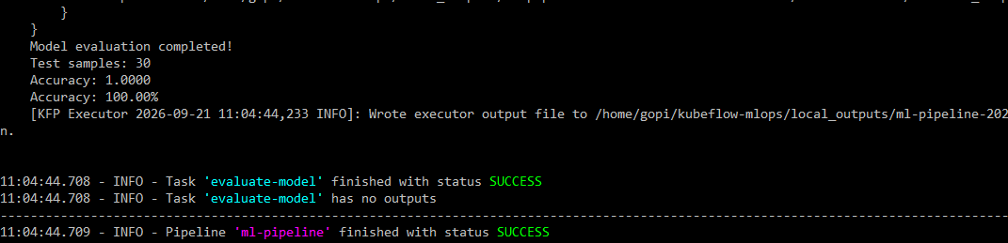

Compile the KFP ML Pipeline
run:
nano compile_pipeline.py

from kfp import compiler
from simple_ml_pipeline import ml_pipeline

compiler.Compiler().compile(
pipeline_func=ml_pipeline,
package_path="simple_ml_pipeline.yaml"
)

print("Pipeline compiled successfully!")
print("Generated file: simple_ml_pipeline.yaml")

run:
python compile_pipeline.py

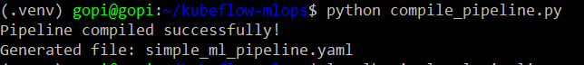

Check the YAML file
Run:
ls -lh simple_ml_pipeline.yaml
You should see something like:
Then:
head -30 simple_ml_pipeline.yaml

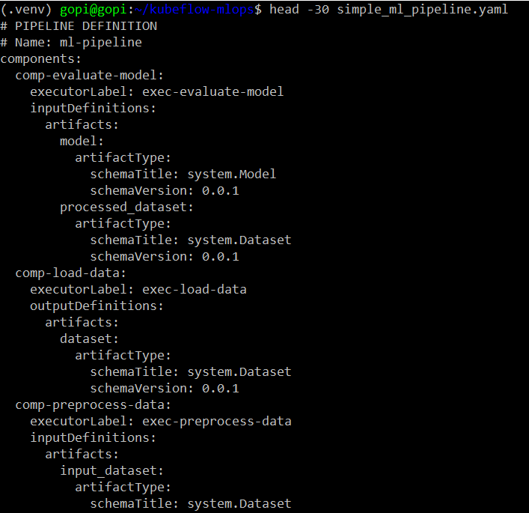

Therefore, modify the bottom of simple_ml_pipeline.py
Change:
local.init(
runner=local.SubprocessRunner()
)

ml_pipeline()

to:

if __name__ == "__main__":

local.init(
runner=local.SubprocessRunner()
)

ml_pipeline()

This is an important Python concept:
if __name__ == "__main__": means execute this section only when the file is run directly, not when it is imported.
So:

Running directly: python simple_ml_pipeline.py

Practical 2 — Run the ML Pipeline with DockerRunner
Docker Desktop Installation Process — Windows + WSL2
Step 1: Check prerequisites
Before installing Docker Desktop, make sure:
- Windows 10/11 is installed
- Virtualization is enabled in BIOS
- WSL2 is installed
- Ubuntu is installed in WSL2
Check WSL from PowerShell:
wsl --status
Then:
wsl -l -v
You should see something similar to:
NAME STATE VERSION
Ubuntu Running 2

Step 2: Download Docker Desktop
Download Docker Desktop for Windows from the official Docker website:
Docker Desktop for Windows (https://www.docker.com/products/docker-desktop/?utm_source=chatgpt.com )
Choose Docker Desktop for Windows.

Step 3: Install Docker Desktop
Run the downloaded installer.
During installation, select:
☑ Use WSL 2 instead of Hyper-V
if that option is presented.
Then continue with the installation.
Restart Windows if Docker Desktop requests it.

Step 4 — Check Docker Desktop on Windows
Open Docker Desktop in Windows.
Go to:
Settings → General
Make sure:
☑ Use the WSL 2 based engine
is enabled.
Then click Apply & Restart if you changed it.

Step 5 — Enable Ubuntu integration
In Docker Desktop go to:
Settings → Resources → WSL Integration
You should see your distributions, including Ubuntu.

Enable:
☑ Enable integration with my default WSL distro
☑ Ubuntu

Then click:
Apply & Restart

Step 6 — Restart WSL
After Docker Desktop restarts, close your Ubuntu terminal.
Open PowerShell or Command Prompt in Windows and run:
wsl --shutdown
Then start Ubuntu again.

Step 7 — Check Ubuntu is WSL2
From PowerShell:
wsl -l -v

You should see something like:
NAME STATE VERSION
Ubuntu Running 2

Docker requires the distribution to be running in WSL 2 mode for this integration.

Step 8 — Test Docker again
Back in Ubuntu:
docker --version
Then:
docker run hello-world
Expected:
Hello from Docker!

Step 9 — Test Python Docker SDK
Once the above works, return to your KFP environment:
cd ~/kubeflow-mlops
source .venv/bin/activate

Then:
python -c "import docker; print('Docker SDK:', docker.__version__)"

And finally:
python -c "import docker; c=docker.from_env(); print('Docker Engine:', c.version()['Version'])"

Next step — DockerRunner Hello World

create the file: nano docker_hello.py

from kfp import dsl
from kfp import local

@dsl.component(base_image="python:3.11")
def hello(name: str) -> str:
message = f"Hello from KFP DockerRunner, {name}!"
print(message)
return message

@dsl.pipeline
def hello_pipeline(name: str = "MLOps Students"):
hello_task = hello(name=name)

# Initialize KFP with DockerRunner
local.init(
runner=local.DockerRunner()
)

# Run the pipeline
hello_pipeline(name="MLOps Students")

Then run:
python docker_hello.py
Next: — Run the ML Pipeline with DockerRunner

Create file:docker_ml_pipeline.py
from kfp import dsl
from kfp import local
from kfp.dsl import Output, Dataset

@dsl.component(
base_image="python:3.11",
packages_to_install=["scikit-learn", "pandas"]
)
def load_data(dataset: Output[Dataset]):

from sklearn.datasets import load_iris
import pandas as pd

iris = load_iris()

df = pd.DataFrame(
iris.data,
columns=iris.feature_names
)

df["target"] = iris.target

df.to_csv(
dataset.path,
index=False
)

print("Dataset loaded successfully!")
print(f"Number of samples: {len(df)}")
print(f"Number of features: {len(iris.data[0])}")
print(f"Number of classes: {len(set(iris.target))}")

@dsl.component(
base_image="python:3.11",
packages_to_install=["pandas", "scikit-learn"]
)
def preprocess_data(
input_dataset: dsl.Input[Dataset],
processed_dataset: Output[Dataset]
):

import pandas as pd
from sklearn.model_selection import train_test_split

# Read dataset
df = pd.read_csv(input_dataset.path)

# Separate features and target
X = df.drop("target", axis=1)
y = df["target"]

# Train-test split
X_train, X_test, y_train, y_test = train_test_split(
X,
y,
test_size=0.2,
random_state=42
)

# Save training data
train_df = X_train.copy()
train_df["target"] = y_train

# Save testing data
test_df = X_test.copy()
test_df["target"] = y_test

train_df.to_csv(
processed_dataset.path + "_train.csv",
index=False
)

test_df.to_csv(
processed_dataset.path + "_test.csv",
index=False
)

print("Preprocessing completed!")
print(f"Training samples: {len(train_df)}")
print(f"Testing samples: {len(test_df)}")

@dsl.component(
base_image="python:3.11",
packages_to_install=["pandas", "scikit-learn", "joblib"]
)
def train_model(
processed_dataset: dsl.Input[Dataset],
model: dsl.Output[dsl.Model]
):

import pandas as pd
import joblib
from sklearn.linear_model import LogisticRegression

# Read training data
train_file = processed_dataset.path + "_train.csv"

train_df = pd.read_csv(train_file)

X_train = train_df.drop("target", axis=1)
y_train = train_df["target"]

print("Training Logistic Regression model...")

classifier = LogisticRegression(
max_iter=200
)

classifier.fit(
X_train,
y_train
)

# Save model
joblib.dump(
classifier,
model.path
)

print("Model training completed!")
print(f"Training samples: {len(train_df)}")

@dsl.component(
base_image="python:3.11",
packages_to_install=["pandas", "scikit-learn", "joblib"]
)
def evaluate_model(
processed_dataset: dsl.Input[Dataset],
model: dsl.Input[dsl.Model]
):

import pandas as pd
import joblib
from sklearn.metrics import accuracy_score

# Read test data
test_file = processed_dataset.path + "_test.csv"

test_df = pd.read_csv(test_file)

X_test = test_df.drop("target", axis=1)
y_test = test_df["target"]

# Load trained model
classifier = joblib.load(model.path)

# Make predictions
predictions = classifier.predict(X_test)

# Calculate accuracy
accuracy = accuracy_score(
y_test,
predictions
)

print("Model evaluation completed!")
print(f"Test samples: {len(test_df)}")
print(f"Accuracy: {accuracy:.4f}")
print(f"Accuracy: {accuracy * 100:.2f}%")

@dsl.pipeline
def ml_pipeline():

# Step 1: Load data
data_task = load_data()

# Step 2: Preprocess data
preprocess_task = preprocess_data(
input_dataset=data_task.outputs["dataset"]
)

# Step 3
train_task = train_model(
processed_dataset=preprocess_task.outputs[
"processed_dataset"
]
)
# Step 4: Evaluate
evaluate_model(
processed_dataset=preprocess_task.outputs[
"processed_dataset"
],
model=train_task.outputs["model"]
)

local.init(
runner=local.DockerRunner()
)

ml_pipeline()

Then run:
python docker_ml_pipeline.py

